**STUDENT ATTENDANCE SYSTEM: DATA FLOW DIAGRAM ANALYSIS**

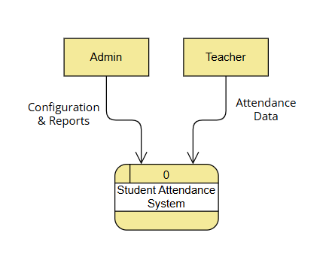

**Fig. 1: Context Data Flow Diagram**

**1. Context Diagram Analysis**

**1.1 System Overview**

The Student Attendance System is an intelligent technological solution to complex challenges that have faced educational institutions in tracking and managing student attendance. It creates a critical interface for the educational stakeholders in transforming the manual traditional attendance methods into streamlined and digitised processes. The context diagram is the architectural blueprint showing how the system interacts with the outside world and what boundaries the system operates within.

**1.2 External Entities Exploration**

**1.2.1 Teacher Entity**

Teachers are the hub in the attendance ecosystem and the direct collectors of this data. Beyond record-keeping, their role represents one very important juncture, one that links institutional tracking with the real-time monitoring of students. The Attendance System modernises that process, moving teachers from a manual way of handling the information to a digital one and allowing them to input data at speed, track anomalies, and intervene early when necessary.

**1.2.2 Administrative Entity**

The administrative users represent the strategic management layer of the attendance system. Their interaction would include system configuration, comprehensive reporting, and strategic decision-making. The administrators use the system to study the long-term attendance trends, correlate attendance with academic performance, make effective utilisation of the institutional resources, and come up with strategies for student engagement.

**1.3 System Boundary Dynamics**

The boundary of the Student Attendance System is an important interface through which technological capabilities are integrated into institutional needs. It acts as an intelligent intermediary in the transformation of raw attendance data into actionable insights. This boundary ensures data integrity and security, with standardised information exchange among all organisational stakeholders.

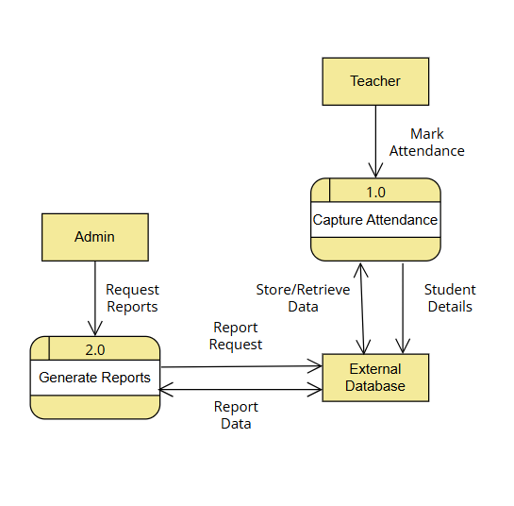

**Fig. 2: Level 0 Data Flow Diagram**

**2. Level 0 Diagram Analysis**

**2.1 Process Decomposition**

**2.1.1 Attendance Capture Process**

Capture Attendance is basically designed to capture the data. It is designed for marking attendance in real time, hence providing the ability to capture a range of input scenarios from daily classroom attendance, tracking in specialised programs, and interfacing with biometric/digital identification systems. The architecture has been designed for flexibility of data entry with immediate validation and seamless integration with the database.

**2.1.2 Generate Reports Process**

Reporting transforms raw data on attendance into strategic intelligence. Besides displaying data in numeric format, it also presents multidimensional reports of trends in attendance, risks of potential disengagement, and performances at institutional levels. There are a range of reports available that can provide an overview on the individual student to a high-level comprehensive institutional report.

**2.2 Data Store Characteristics**

The external database will be an intelligent repository, much more than a simple storage facility. It enables complex queries, supports historical data analysis, and provides a secure and scalable infrastructure of attendance information. The design of the database ensures consistency in data, allows for multiple concurrent users, and enables fast information retrieval.

**3. Advanced System Considerations**

**3.1 Architectural Flexibility**

This also means that the architecture of the system is highly flexible to accommodate diverse educational environments. The attendance system, whether implemented in a single and small school or a large multi-campus organisation, retains its core functions while allowing for customisation.

**3.2 Technological Potential**

Future versions of the system might use advanced technologies like machine learning to predict attendance analysis, AI for automated interventions, and analytics platforms linking attendance to broader educational outcomes.

**Conclusion**

The Student Attendance System goes beyond being a recording tool to becoming an intelligent technological solution, which completely flips around the paradigm of attendance management. The clarity in approach and structured nature of data flow and interactions raise the bar that it presents for educational technology infrastructure.

**Appendix**

* Diagrams Reference: Context and Level 0 Data Flow Diagrams
* Notation Standard: Gane and Sarson